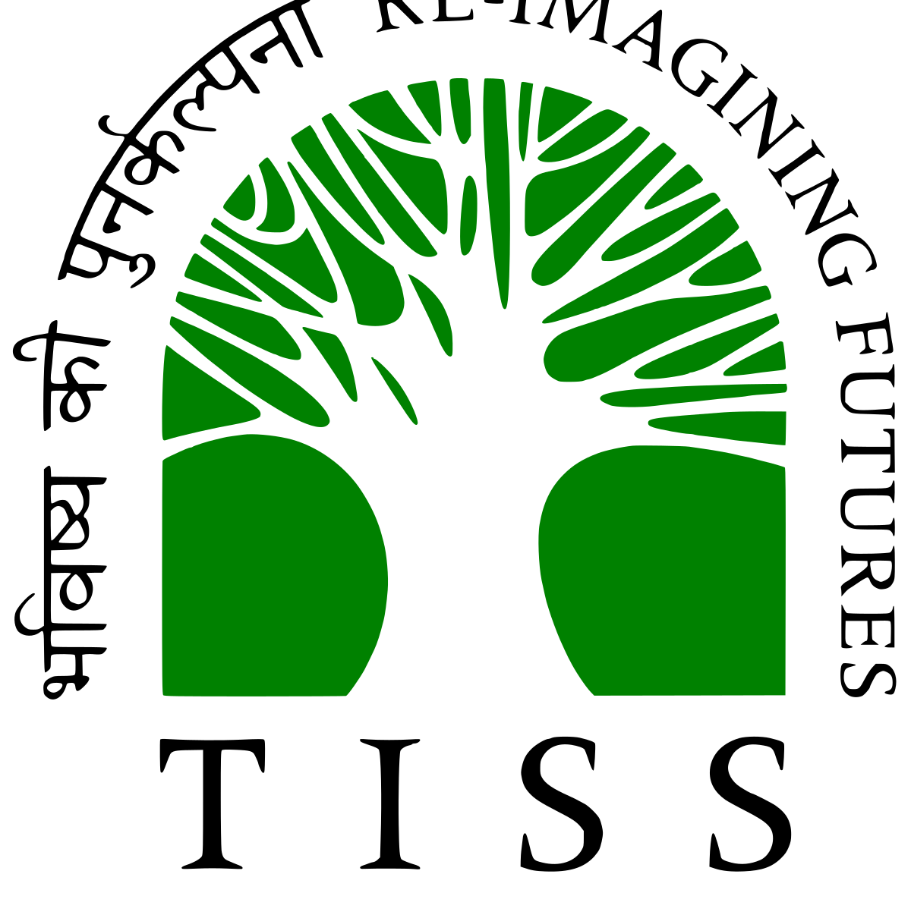

Aryan Prakash
Aspiring Data Analyst | M.Sc. Analytics Student at TISS
ộ Mumbai, India O +91-9773734232 @ aryanpr456@gmail.com

Profiles aryanprakash aryan-prakash-7661a2322/ aryanpr456

Summary Data analytics enthusiast pursuing M.Sc. in Analytics at Tata Institute of Social Sciences, with a strong foundation in statistics, programming, and business problem-solving. Skilled in Python, SQL, and visualization tools. Passionate about deriving actionable insights from data to support decision-making and business growth.

Education Tata Institute of Social Science
MA/MSC in Analytics

Core Competencies (Through Academic Curriculum):
Statistical Analysis & Hypothesis Testing Python Programming for Data Analysis
R for Statistical Computing
Interactive Dashboard Design & Data Storytelling (Tableau, Power BI) Mathematical Foundations for Analytics

Swami Shraddhanand College, University Of Delhi
Bachelor of Life Science

Tagore Academy, Faridabad (PCB)

Rawal Convent School, Faridabad

2025 - 2027
Full Time

2021-2024
Full-time
82.8%

2018-2019
86.4%

2017
10cgpa

Skills Soft Skills:
Communication, Team Collaboration, Time Management, Problem-Solving

Analytical Thinking:
Logical reasoning, Data interpretation, Report presentation

Interests Reading (specially sci-fi and self-help) Chess (peak online rating:1800)

Certifications MS Excel
(ongoing)

MySQL

Awards Secured City Rank 2, State Rank 12, and International Rank 32 in the National Science Olympiad
(NSO); awarded a medal

